For classification algorithms, here we have worked on the dataset,”Social_Network_Ads.csv”, for which we have the values for the below metrics:
SVM:
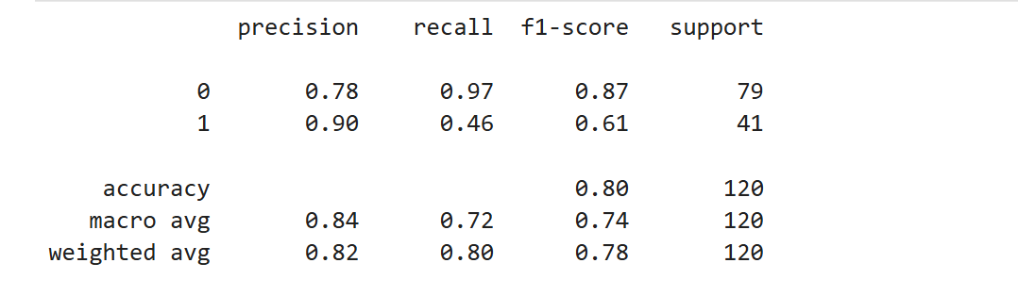
- What is the overall performance of the model?
Accuracy: 80%

- Which metric measures overall correctness?
Accuracy: 80%
- What percentage of all predictions were correct?
Accuracy: 80%
- Out of all actual purchased people, how many did the model detect?
Recall: 0.46 or 46%
- Out of all actual purchased people, how many were correctly identified?
Recall: 46%
- Out of all not purchased people, how many did the model detect?
Recall: 0.97 or 97%
- Out of all not purchased people, how many were correctly identified?
Recall: 97%
- Out of all transactions predicted as purchased, how many actually purchased?

Precision: 90% or 0.90

- If the model labels a customer as purchased, what is the probability that they have actually purchased?

Precision: 90% or 0.90

- Out of all transactions predicted as not purchased, how many actually not purchased?
Precision: 78% or 0.78

- If the model labels a customer as not purchased, what is the probability that they have actually purchased?
Precision: 78% or 0.78
- How well does the model balance precision and recall for the purchased set?
F1 Score: 61%
- How well does the model balance precision and recall for the not purchased set?
F1 Score: 87%

- What is the harmonic mean of precision and recall when considering not purchased ones?

F1 Score: 87%
- What is the harmonic mean of precision and recall when considering purchased ones?
F1 Score: 61%

Random Forest:
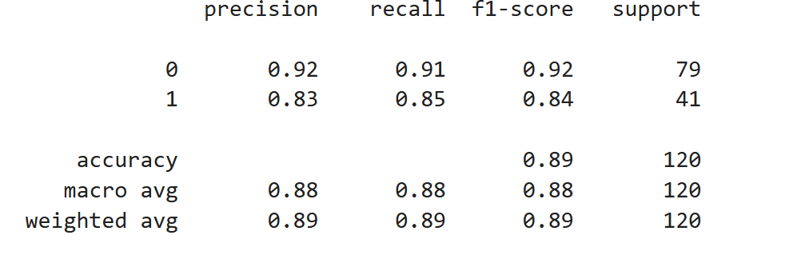
- What is the overall performance of the model?
Accuracy: 89%

- Which metric measures overall correctness?
Accuracy: 89%
- What percentage of all predictions were correct?
Accuracy: 89%
- Out of all actual purchased people, how many did the model detect?
Recall: 0.85 or 85%
- Out of all actual purchased people, how many were correctly identified?
Recall: 85%
- Out of all not purchased people, how many did the model detect?
Recall: 0.91 or 91%
- Out of all not purchased people, how many were correctly identified?
Recall: 91%
- Out of all transactions predicted as purchased, how many actually purchased?

Precision: 83% or 0.83

- If the model labels a customer as purchased, what is the probability that they have actually purchased?

Precision: 83% or 0.83

- Out of all transactions predicted as not purchased, how many actually not purchased?
Precision: 92% or 0.92

- If the model labels a customer as not purchased, what is the probability that they have actually not purchased?
Precision: 92%
- How well does the model balance precision and recall for the purchased set?
F1 Score: 84%
- How well does the model balance precision and recall for the not purchased set?
F1 Score: 92%

- What is the harmonic mean of precision and recall when considering not purchased ones?

F1 Score: 92%
- What is the harmonic mean of precision and recall when considering purchased ones?
F1 Score: 84%

Decision Tree:
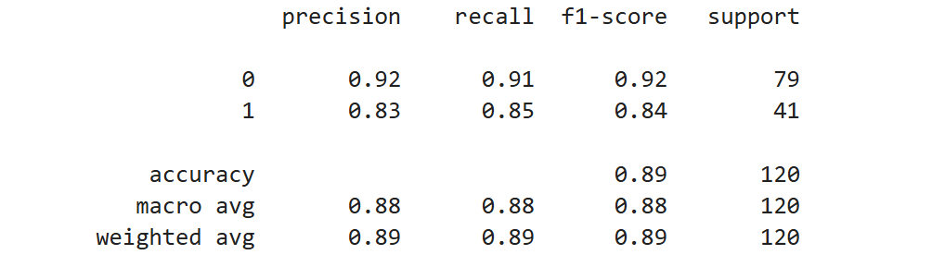

- What is the overall performance of the model?
Accuracy: 89%

- Which metric measures overall correctness?
Accuracy: 89%
- What percentage of all predictions were correct?
Accuracy: 89%
- Out of all actual purchased people, how many did the model detect?
Recall: 0.85 or 85%
- Out of all actual purchased people, how many were correctly identified?
Recall: 85%
- Out of all not purchased people, how many did the model detect?
Recall: 0.91 or 91%
- Out of all not purchased people, how many were correctly identified?
Recall: 91%
- Out of all transactions predicted as purchased, how many actually purchased?

Precision: 83% or 0.83

- If the model labels a customer as purchased, what is the probability that they have actually purchased?

Precision: 83% or 0.83

- Out of all transactions predicted as not purchased, how many actually not purchased?
Precision: 92% or 0.92

- If the model labels a customer as not purchased, what is the probability that they have actually not purchased?
Precision: 92%
- How well does the model balance precision and recall for the purchased set?
F1 Score: 84%
- How well does the model balance precision and recall for the not purchased set?
F1 Score: 92%

- What is the harmonic mean of precision and recall when considering not purchased ones?

F1 Score: 92%
- What is the harmonic mean of precision and recall when considering purchased ones?
F1 Score: 84%

